The Psychology of Magic: Introduction
Chris Senhouse

Salvador Dali's Metamorphosis of Narcissus studies the nature of psychoanalysis
As I'm sure most of you out there also do, I find Magic to be a pretty fascinating game. Back when I was a student at Cornell, I took a minor in psychology, focusing on perceptual psychology. However, I'm also interested in personality psychology, of which one branch is sports psychology. Magic as an intellectual endeavor brings about a lot of the same issues that physical sports do, and I'm curious what factors separate successful Magic players from unsuccessful ones from the mental and psychology perspective.
Here's one definition of sport psychology that I found in my research:
"Sport psychology involves preparing the mind of an athlete, just as thoroughly as one prepares the body."
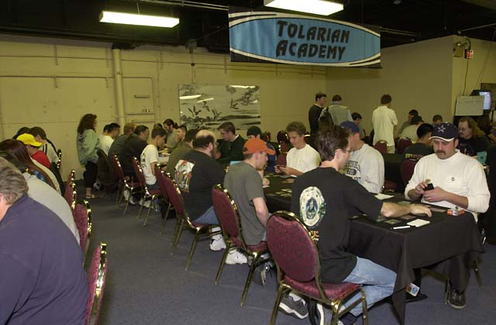
To relate this to Magic, I'd like to propose the following corollary definition:
Magic psychology involves preparing the mental approach of a Magic player, just as thoroughly as one prepares the player's tactical reasoning and abilities.
I plan to explore various facets of existing methods used in sports psychology and to attempt to relate and template these for Magic. I will also be investigating the preparation and approaches used by other "mind sports" (as explained in Aaron Forsythe's excellent Star City article found here.) and attempt to see if they can be useful as well. Some topics I plan to cover are goal setting, motivation, imagery, what it means to be "in the zone," focus and concentration methods, relationships between anxiety and performance, and the "inner game." I hope that you find these articles at least interesting, and hopefully even useful. Feel free to email any comments to senhouse@aol.com.
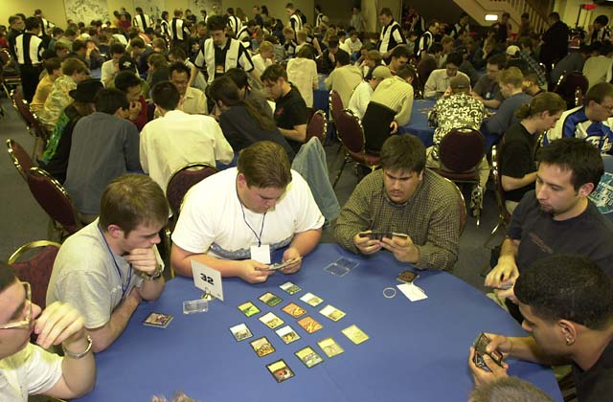
One of the primary inspirations for this series is an article titled "The Zen of Magic," and can be found at the web site that I used to maintain, The Dojo. I remember first reading this article and being fascinated at its view at Magic from a "higher level" and the concept that there is more to a given game of Magic than just the decks and the cards drawn. Check it out here.
As a start, I'm going to lead off with a personal experience which I've affectionately called "The Chuck Knoblauch Effect."

The Psychology of Magic Part One: The Chuck Knoblauch Effect
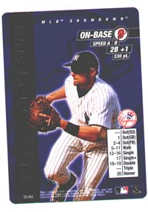
I love sports, particularly ice hockey, but I only really pay attention to baseball during the playoffs. During the regular season, I pretty much just watch how the Boston Red Sox are doing and vaguely follow the New York Mets and the New York Yankees. During the past baseball season, one player's story particularly interested me.

The loss of perspective that can ensue can be very damaging to the psychological undercurrents of both confidence and humility.
The Yankees' second baseman Chuck Knoblauch was traded to the team before the 1998 season from the Minnesota Twins after playing with them since 1991. A reasonably solid leadoff man, he had been a consistent near-.300 hitter for his whole career and was solid defensively, winning four Gold Glove awards. However, somehow during the 2000 season, Chuck began to develop a small problem. A few missed throws to first base seemed to have affected his subconscious confidence, and they beget more errors. Pretty soon, Chuck had almost lost the ability to make even the most routine of these ground ball plays, and he ended up getting 15 official errors recording during the first half of the 2000 season. It got so bad that Chuck was asked to become a designated hitter and relinquish his fielding position.
How did this happen?
We're talking about a guy who has taken these routine ground balls and thrown them to first for his entire life. He was able to do this so well with non-routine plays that he was able to win awards for his fielding! Chuck decided, and presumably correctly, that his problem could not be physical (including what is usually called "motor memory" - the training of one's nervous/muscular system to adapt to specific repeated actions) but must instead somehow be caused by his mental approach, something in his psyche. He has met with various sports psychologists and is currently hoping to have cured this problem before the 2001 season.

A Personal Recollection
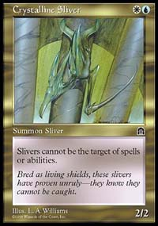
For the past six months, I've felt like the Chuck Knoblauch of Magic. While I've had my share of success, including a Top 4 at the Pro Tour New York Masters Gateway, a Qualifier Top 8 with my favorite deck (Counter-Sliver), and making Day 2 of Grand Prix New Orleans with a 6-1 Day 1 record, my overall success in the past six months has not been either to the level I really want or to the levels I had attained in the past. This made me question a number of things, including my desire to maintain the level of commitment to the game that I've had.
During this stretch of disappointing results, I've had the strange experience of going through some strategic logic, being relatively sure of the "right play," and then somehow managing to convince myself to pursue a different and incorrect thought process. I almost immediately recognize my mistake after I make it, although forcing myself to play slower has yet to help me here.
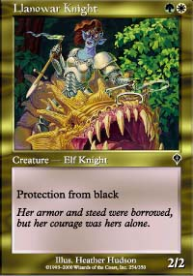
An embarrassing example of this was when I had three black creatures and one red creature out and my opponent had a Llanowar Knight among some other creatures. I had done the mental realization that attacking with at least two of my black creatures would force him to have to block, and the separate thought that I needed to leave the red creature back to block. Somehow my mind incorrectly followed the "attacking" thought process and I foolishly sent all my creatures (with a black creature to cast in my hand) although it was clear that he could block in a way that he would survive and be able to attack back with his Llanowar Knight... and I was at 2 life. I had the correct strategic analysis in my brain, but somehow I managed to twist it around in action and lose a game I should have easily won.
I've also found myself realizing important yet subtle technical plays right after the window of opportunity for them passes. A simple example to illustrate this would be a Limited game where my opponent is playing blue-black and I have out an important dominant creature. My mind screams "He has Recoil!" right after I play a land, emptying my hand. These kinds of things used to come as automatic for me as I'm sure a simple catch and toss to first base used to come to Knoblauch.
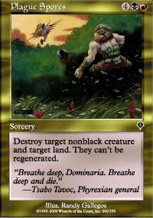
My opponents always seem to topdeck, I rarely seem to draw the cards I need. If I choose to Plague Spores my opponent's Mountain, not only does he/she undoubtedly draw a mountain next, but then drops a insanely good green spell the next turn off the solitary Forest I could have destroyed. I feel like I'm constantly facing judgment calls that truly feel to be 50-50, but somehow it always turns out that I make the wrong choice. I consistently lose to players who would best be described as "newcomers." My sealed decks always feel terrible.

Do I need to see a psychiatrist?
So now the question is, like it was for Knoblauch, "how did this happen?" Am I going through a truly unlucky phase? Have I somehow lost some of my intelligence or the things I've learned about Magic through practice? Why have the "routine ground balls" become struggles? I believe in internalizing rather than externalizing problems, which is usually beneficial for improving at something like Magic. I don't like to blame mana screw, or opponent's top decking skills, or how hard it's snowing. I want to figure out what I did incorrectly and I want to learn how I could have given myself the best chance to succeed This is a key issue in any game with any inherent randomness, which includes Magic, poker, backgammon, and even Monopoly. It's what you talk about when you "play the odds" and it's something that is very common in baseball. A single play in baseball is relatively insignificant statistics-wise, because so many games (164) are played during every season - it's the long term that counts. You can't be too excited when you win or too depressed when you lose, because that will just accentuate the "local" minimums and maximums. The loss of perspective that can ensue can be very damaging to the psychological undercurrents of both confidence and humility.
I don't know if I will ever reach the levels I've accomplished in Magic in the past again (qualifying for three Pro Tours, including one Team Pro Tour with Joel Frank and Michelle Bush) but I'm very curious what it will take to overcome the current slump I feel like I'm in. Do I need to try to ignore it and put it past me? I've tried this sort of thing but the problem seems to come back to haunt me over and over. Do I need to take time away from the game to clear my mind of it and to get a fresh perspective? Do I need to see a psychiatrist? I'm curious what the best players do to avoid falling into these sort of slumps, if anything - it might possibly be that the best players have a different personality makeup.

Psychoanalysis and Anxiety Disorders
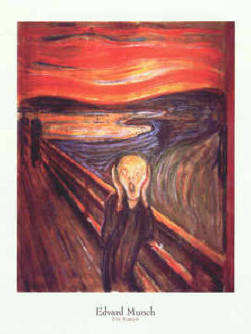
I find this phenomenon to be interesting, as it has never happened to me to this degree in the past. It seems that the best players are able to "shrug these things off" and continue to enjoy the game and perform at a high level. The Chuck Knoblauch Effect is exactly the kind of issue that sport psychology tries to address. As is found in alcoholism treatment, one of the buzzwords used here is intervention. A sports psychologist might help a Chuck Knoblauch through a variety of methods, traditionally based on behavioral adaptation techniques. These include things that future articles in this series might explore, such as relaxation training, breathing techniques, and visualization. For now, however, I'd like to discuss how and why many sport psychologists view this kind of phenomenon as an exception to the behavioral paradigms typically used. The "Chuck Knoblauch Effect" falls under the same tree as other anxiety disorders such as claustrophobia and obsessive compulsiveness. Tom Ferrarro, Ph.D., writes:
"Symptoms of anxiety as they relate to unconscious conflicts are psychoanalytic ideas. Both the motivation to compete in sports and conflicts about winning are largely unconscious and cognitive-behavioral interventions have little to contribute in the study of these areas."
To address an athlete (or Magic player)'s subconscious performance anxiety, one could look at a number of psychoanalytic factors. We've heard sports coaches tell their players things like "refuse to lose" and "let's stop being scared to win" - and it turns out that the fear of winning can actually be a very powerful hidden force. It is a manifestation of a common neurosis that most of you have heard of, separation anxiety. The idea in this particular case is that by winning at a sport, the competitor feels as if they are separating themselves from the losers, from the crowds, from their family.
"Guilt over winning is an unconscious but powerful barrier."
Another factor, which can influence a competitor's psyche, is the level of cohesion in his or her self-esteem. A player with high self-esteem will be able to "brush it off" when things go poorly, while a player with low self-esteem will typically react to difficulty with either feelings of anger or desperation. The pressures present during a competitive setting can induce these factors into a temporary state of psychosis. Here's a compelling story on that note:
"I recall a professional golfer leading a major a few years ago with only six holes to play. He had a fifteen foot putt on a par three and as he walked to the green he reported noticing the beauty of the trees on this course. He became obsessed with the "beauty of nature" for the last six holes as he proceeded to bogey in, thereby losing the tournament and also his reality for a few hours."
Certain traumas, trainings or difficulties in psychological development can lead to internal conflicts and inhibitions of aggression, which is a key component in being able to be successful in a competitive setting. The last factor I'd like to discuss is also interesting - the idea that by not winning, the competitor's psyche can subconsciously rationalize it if it has been reinforced through secondary gain. You imagine this line of reasoning in a Magic player's subconscious: "I know I'm good enough to win this qualifier, but I can win a lot of prizes by just making the Top 8."
In conclusion, the factors that might cause a player's "Chuck Knoblauch" effect can be very varied, very subconscious, and very powerful. Take the time to carefully consider whether any of these forces might be affecting your mental approach to Magic tournaments - it might be the best thing you've ever done.

